
Visual Cobol 11: Client Server Binding

Version1.0
Last updated: Monday, December 15, 2025

Introduction
Client/server binding is a remote procedure call mechanism, for use with 300 clients or fewer, to implement a lightweight client/server architecture. When used with CCI, the Client/Server Binding works by having a copy of mfserver running on the server tier; this copy of mfserver communicates with any and all clients using an agreed server name. The mfserver module can be run using built-in defaults.
To use the Client/Server binding in your application you need to:
- Create a configuration (.cfg) file to control the behaviour of mfclient and mfserver modules and the communications connection.
- Add code to your client program to call the mfclient module
- Add code to your server program to enable it to be called by the mfserver module
Each of these steps are explained in more detail below with examples. Further detailed information can be found on the rocket documentation website under Client/Server Binding.

Required Files
- mfserver.exe
- mfclisrv.cpy
- mfclient.dll

Client and Server modules
The mfserver and mfclient modules pass information to each other via a parameter block described in the mfclisrv.cpy copybook. The modules use the same parameter block to pass information to any user programs.
Your server program must include the copyfile, mfclisrv.cpy in the Linkage Section. You must also modify the Procedure Division header to include the parameter block, LNK-PARAM-BLOCK, which is used to pass parameters from mfserver.

Examples
The examples below explain and demonstrate two approaches to implement the Client/Server bind. Each example provides an overview of the program flow of the application and detailed instructions to setup each application. The examples are provided in the CSBind-Examples.zip with the folder structure listed as below:
- CS-WinForms-FrontEnd
  - Client
    - Client.cbl
    - Client.dll
    - ClientFrontEnd.exe
    - Form1.cs
    - mfclient.dll
    - mfclisrv.cfg
    - mfclisrv.cpy
    - MicroFocus.COBOL.Runtime.dll
    - NativeCobolClient.cbl
    - NATIVECOBOLCLIENT.DLL
    - Setup.bat
  - Server
    - mfclisrv.cpy
    - mfserver.exe
    - serverFileHandle.cbl
- Green-Screen
  - Client
    - callToMfclient.cbl
    - callToMfclient.exe
    - mfclient.dll
    - mfclisrv.cfg
    - mfclisrv.cpy
    - setup.bat
  - Server
    - mfclisrv.cpy
    - mfserver.exe
    - serverFileHandle.cbl

Green Screen

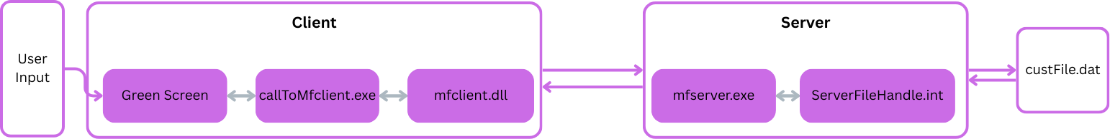
Overview

The Green Screen example demonstrates a simple COBOL screen application where a user issues a query to a server program to retrieve data for display, using the Client/Server Binding modules. To setup and execute this example, the following steps are required:

Server Setup
- Replace the mfserver.exe with the given patched mfserver.exe

  - Go to the server directory of the Green Screen example
  - Locate the installation of Visual Cobol bin directory
This is usually under C:\Program Files (x86)\Rocket Software\Visual Cobol\bin

  - Replace the mfserver.exe under the bin directory of Visual cobol with the given mfserver.exe

- Go to ESCWA (localhost:10086) and disable listen on loopback only

  - On ESCWA go under Navigation – Directory Servers – Default – Properties
  - Uncheck the box for Listen on Loopback Only (Requires Directory Server restart)

- Restart your device (computer) to update the path

- Open a 32-bit Visual Cobol Command Prompt inside the Server folder of the Green Screen directory.

- Compile the server-side program to a 32-bit .int so mfserver.exe can execute serverFileHandle.cbl when a client request is made:
Command: cobol serverFileHandle.cbl CASE INT(serverFileHandle.int);
The compiled server-side program should reside in the same directory as mfserver.exe.

- Start the server program.
Command (32-bit Visual COBOL Command Prompt): run mfserver [-s Server Name] [-b]
For this example, we will run: run mfserver -s demo -b

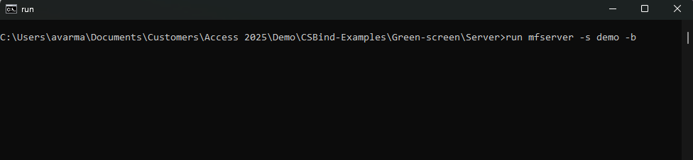
The command will show no confirmation however the server is running.

If no arguments are provided, the server’s name defaults to “MFCLISRV”.
To verify the server is running, check ESCWA (localhost:10086) under:
Navigation – Directory Servers - Default

Client Setup
- Open a 32-bit Visual Cobol Command Prompt inside the Client folder of the Green Screen directory.

- Compile the callToMFclient.cbl as a 32-bit executable (the client-side application):
Command: cbllink callToMFclient.cbl

- Create a configuration file to control the behaviour of the mfclient and mfserver modules.
  - Create a mfclisrv.cfg file.
  - Include the three following required arguments:

[mf-clisrv]
dblksize=<Amount of Memory to Allocate for data transfer>
srvprog=<Server-side Program to be called by mfserver>

For this example the configuration file will include an additional parameter called servername to indicate the name of the server. This parameter is defaulted to MFCLISRV. The file should look like this:

[mf-clisrv]
dblksize=64
srvprog=serverFileHandle
servername=Demo

- In the directory of the client program run the included setup.bat file to set two environment variables:
CCITCP2 and MFCSCFG.

The setup.bat file takes in two arguments: ServerHostName (required), ConfigPath (Optional).
The ServerHostName argument is used to direct mfclient which device to look for. This can be the hostname of your server device or the IP.

The ConfigPath argument is the pathname to configuration file.
This is defaulted to MFCSCFG=mfclisrv.cfg where mfclisrv.cfg is in the current directory of mfclient.dll.

Command: setup.bat (your device hostname)

The pathname of MFCSCFG cannot be greater than 128 characters.
- Run the compiled client application callToMFclient.exe using the command in a 32-bit Visual Cobol

Command Prompt: run <clientProgramName> <PathToConfig>/mfclisrv.cfg
For this example, we will run: run callToMFclient.exe mfclisrv.cfg

C# WinForms

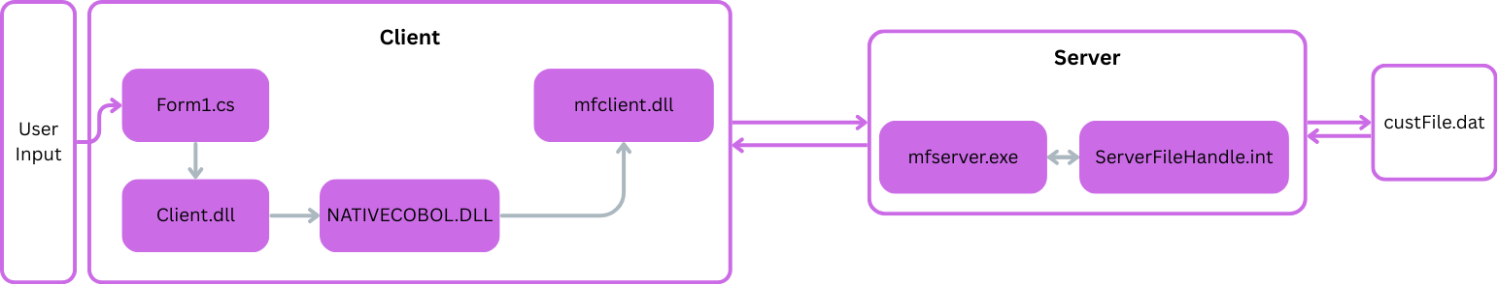
Overview
The C# WinForms example demonstrates a .NET WinForms front end interacting with native COBOL utilising the client/server binding modules. It replicates the core workflow of the previously described “green screen” example of a user submits a query to retrieve data from a server-side .dat file, with instead a .NET C# WinForms application. To setup and run this example follow these steps:

Server Setup
Steps 1-3 can be skipped if they were completed in the green screen example above.
- Replace the mfserver.exe with the given patched mfserver.exe
  - Go to the server directory of the Green Screen example
  - Locate the installation of Visual Cobol bin directory
This is usually under C:\Program Files (x86)\Rocket Software\Visual Cobol\bin

  - Replace the mfserver.exe under the bin directory of Visual cobol with the given mfserver.exe

- Go to ESCWA (localhost:10086) and disable listen on loopback only

  - On ESCWA go under Navigation – Directory Servers – Default – Properties
  - Uncheck the box for Listen on Loopback Only (Requires Directory Server restart)

- Restart your device (computer) to update the path

- Open a 32-bit Visual Cobol Command Prompt inside the Server folder of the CS-WinForms-FrontEnd directory.

- Compile the server-side program to a 32-bit .int so mfserver.exe can execute serverFileHandle.cbl when a client request is made:
Command: cobol serverFileHandle.cbl CASE INT(serverFileHandle.int);
The compiled server-side program should reside in the same directory as mfserver.exe.

- Start the server program.
Command (32-bit Visual COBOL Command Prompt): run mfserver [-s Server Name] [-b]
For this example, we will run:

run mfserver -s demo -b

The command will show no confirmation however the server is running.

If no arguments are provided, the server’s name defaults to “MFCLISRV”.
To verify the server is running, check ESCWA (localhost:10086) under:
Navigation – Directory Servers - Default

Client Setup
This example uses Visual Studio 2022 with Visual Cobol 11 to develop the example. To learn more about how to create this application visit the Rocket Software documentation about .NET COBOL Programming.
- Create a 32-bit Native Cobol Client application to call the client/server bind modules.
These files are included in the client folder of the CS-WinForms Folder as NativeCobolClient.cbl and NATIVECOBOLCLIENT.DLL.

- Create a 32-bit Class Library to interact with the Native cobol client and the C# .NET WinForms application.
These files are included as: Client.cbl, Client.dll
- Create a C# .NET WinForms application with references to the client Class Library and the MircroFocus.COBOL.Runtime.

These files are included as: ClientFrontEnd.exe, Form1.cs, MicroFocus.COBOL.Runtime.dll
- Create a configuration file to enable the client to control the behaviour of the mfclient and mfserver modules.

  - Create a mfclisrv.cfg file.

  - Inside the config file three arguments are required:
[mf-clisrv]
dblksize=<Amount of Memory to Allocate for data transfer>
srvprog=<Server-side Program to be called by mfserver>

For this example, the configuration file will include an additional parameter called servername to indicate the name of the server. This parameter is defaulted to MFCLISRV. The file should look like this:

[mf-clisrv]
dblksize=64
srvprog=serverFileHandle
servername=Demo

- In the directory of the client program run the included setup.bat file to set two environment variables:
CCITCP2 and MFCSCFG.

The setup.bat file takes in two arguments: ServerHostName (required), ConfigPath (Optional).
The ServerHostName argument is used to direct mfclient which device to look for. This can be the hostname of your server device or the IP.

The ConfigPath argument is the pathname to configuration file.
This is defaulted to MFCSCFG=mfclisrv.cfg where mfclisrv.cfg is in the current directory of mfclient.dll.

Command: setup.bat (your device hostname)
- Run the .NET C# WinForms application in a 32-bit Visual Cobol Command Prompt with the configuration file.

Command: run ClientFrontEnd.exe mfclisrv.cfg

- Enter 00000001 into the Enter Record Number Field and click the GetData button.

Additional Tips
If you are experiencing any errors/hangs or unexpected problems, check the following steps to debug.
- Check the journal in ESCWA under
  - Navigation – Directory Servers – Default – Journal
  - Filter for the server name and check the logs
- Check both server and client run directories for log files:
  - ccierr.log
  - mfclisrv.log
  - mfdebug.log
- Run the CCITCP2.exe included in the Additional Debug folder and restart your device

